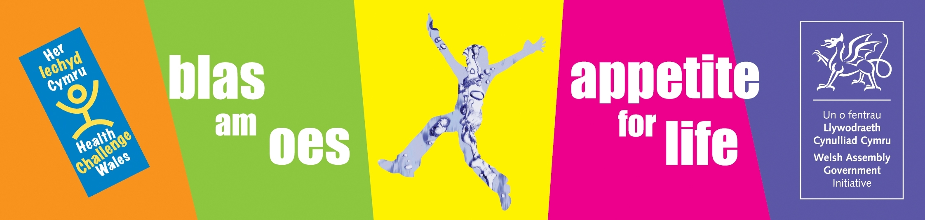

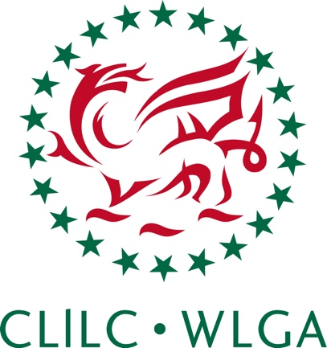

THE HEALTHY EATING IN SCHOOLS
EVIDENCE GUIDE AND TOOLKIT

A GUIDE TO DEMONSTRATE COMPLIANCE WITH THE HEALTHY EATING IN SCHOOLS (NUTRITIONAL STANDARDS AND REQUIREMENTS) (WALES) REGULATIONS 2013

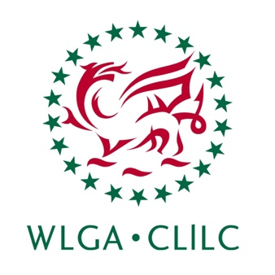
The purpose of this guide is to assist school meal providers, head teachers, governors and other partners who have an interest in school food and drink, to understand and collect evidence to demonstrate compliance with the Healthy Eating in Schools (Wales) Regulations 2013.
CONTENTS

Section |  |  | Page
1. | Introduction |  | 3
2. | Demonstrating compliance with the regulations |  | 5
3 | Responsibilities for complying with the regulations |  | 6
4. | Types of evidence to demonstrate compliance |  | 9
 | 4.1 | Evidence to demonstrate meeting the nutrient standards | 10
 | 4.2 | Evidence to demonstrate meeting the food and drink standards | 12
5. | Using the evidence |  | 13
6. | The Healthy Eating in Schools Evidence Toolkit |  | 14
7. | Resources & supporting documents |  | 15
 | 7.1 | Definitions table | 15
Annex 1 |  | Blank Healthy Eating in Schools Evidence Toolkit for Primary Schools | 16
Annex 2 |  | Blank Healthy Eating in Schools Evidence Toolkit for Secondary Schools | 23
Annex 3 |  | Blank Healthy Eating in Schools Evidence Toolkit for Maintained Nursery Schools | 30
Annex 4 |  | Completed example of Healthy Eating in Schools Evidence Toolkit for Primary Schools | 36
Annex 5 |  | Drink standard checklist | 52

1. Introduction

This guide has been developed by the WLGA to assist school meal providers (SMP) to collect evidence which will help them demonstrate compliance with The Healthy Eating in Schools (Nutritional Standards and Requirements) (Wales) Regulations 2013. It provides details of the types of evidence that can be used to demonstrate compliance to the nutrient and food standards. However, SMP may wish to gather other information and/or further evidence than described here.

The Healthy Eating in Schools Regulations 2013 came into force on 2 September 2013 in all maintained school settings. This includes all local authority maintained nursery, primary, middle, secondary and special schools and pupil referral units. The Regulations have been given a statutory basis under Section 4 of the Healthy Eating in Schools (Wales) Measure 2009.

The Regulations require all food and drink provided throughout the whole school day in all maintained schools to meet the statutory standards.

Full details of the Healthy Eating in Schools Regulations are available in the Statutory Guidance.
This guide includes:

    - Information on:
      - Demonstrating compliance with the regulations
      - Responsibilities for complying with the regulations
      - Types of evidence to demonstrate compliance
      - Using the evidence

- The Healthy Eating in Schools Evidence Toolkit
A resource to help SMP collect evidence to demonstrate meeting the Healthy Eating in Schools Regulations 2013.

- The Healthy Eating in Schools Evidence Toolkit consists of:
      - Part 1. Information table
      - Part 2. Evidence checklist
      - Part 3. Food categories form for school breakfast
      - Part 4. Food standards form for food served at lunch
      - Part 5. Food standards form for food served outside breakfast and lunch
      - Part 6. Nutrient standards list

2. Demonstrating compliance with the regulations

SMP will need to show how they meet the Healthy Eating in Schools Regulations 2013. This will require them to provide information to evidence meeting the:

1. Nutrient standards for lunch time (excl. nursery schools)

2. Food based standards across the whole school day;
- Breakfast provision
- Break times
- Lunch times
- After school clubs
- Additional serving outlets: vending machines, 6th form cafes, tuck shops etc

3. Drinks based standards
Including:
- Free access to drinking water (requirement under Section 5 of the Healthy Eating in Schools (Wales) Measure 2009)

See section 4 for information on the types of evidence that can be collected to demonstrate compliance. See section 6 for information about the Healthy Eating in Schools Evidence Toolkit – a resource to help you evidence compliance with the regulations.
3. Responsibilities for complying with the regulations

School breakfast
School breakfast can be an additional food service provided to pupils to ensure a healthy start to the school day. However, there is no legal obligation to provide school breakfasts.

Free school breakfast can be available in all local authority maintained primary schools. If a school governing body requests free breakfast provision this must be provided by the local authority. The local authority can decide to depart from this provision; however they must have clear and justifiable reasons for doing so. Please see the Free Breakfast in Primary Schools (FBIPS) statutory guidance for more information.

Schools may decide to set up an independent breakfast club. All breakfast provision, regardless if it’s a free school breakfast or paid breakfast, it must comply with the breakfast food categories in the Healthy Eating in Schools Regulations. This includes breakfast provided in nursery, primary, secondary, special schools or pupil referral units. Responsibility lies with the breakfast provider to ensure compliance with the regulations.

School lunch
The responsibility for the provision of a paid school meals service or a free school meals service to eligible pupils and deciding the form of school meals lies with the local authority or school governing body where the function has been delegated.

Where a school has a delegated budget for meals, the school governing body takes on the same responsibility as the local authority in connection with their provision. Schools with delegated budgets are free to buy back into local authority catering services if the local authority agrees.

Through the school meal contract, responsibility for day to day provision may be discharged to the service provider (e.g. a private catering company). However, the responsibility for the provision of school meals still remains with the local authority or with the school governing body where the function has been delegated. Therefore, roles and responsibilities for providing evidence of compliance will vary depending upon the nature of the catering service.

Food provision by the local authority
Where catering is provided by a local authority, the local authority should carry out the necessary menu planning and nutrient analysis. The local authority should compile and provide evidence to demonstrate meeting the nutrient and food standards.

Food provision by the school
Where the budget has been delegated to the school and the food is provided by the school, the school governors are responsible for ensuring the food meets the food and nutrient standards. The school should carry out the necessary menu planning and nutrient analysis and compile the evidence for meeting the nutrient and food standards.

Food provision by private catering contractors
Where a local authority or an individual school contracts the service to private contract caterers, the contract should state that all food provision must comply with the Healthy Eating in Schools Regulations 2013. The catering company should compile and provide evidence to demonstrate meeting the nutrient and food standards. It is the local authority or school’s responsibility to ensure the contract caterer is complying with the nutrient and food standards.

Food served outside lunchtime provision
Where there is a mixed provision for food, e.g. lunch is provided by the local authority but the school run a tuck shop or an after school club, the provider of the food is responsible for ensuring the food served at these times meets the food and nutrient standards. Therefore, where the local authority has made arrangements for food provision (e.g. lunch time provision), the local authority is responsible for ensuring the standards are met at that time. If the school has also made arrangements for food provision (e.g. tuck shops, after school clubs) the school governors are responsible for ensuring the standards are met at those times.

In these cases, it is very important that there is good communication between the different providers to ensure that all the standards are met throughout the whole school day.

In summary:
Those that make the arrangements for food provision in schools (school governors and/or local authority) are responsible for ensuring the food meets the standards and are also responsible for providing evidence to show that provision meets the standards.
4. Types of evidence to demonstrate compliance

SMP are legally obliged to comply with the Healthy Eating in Schools Regulations 2013 under the Healthy Eating in Schools Measure 2009.

Collecting evidence to demonstrate compliance should be undertaken to satisfy providers that their provision meets the standards since it is the providers’ responsibility to ensure the regulations are met.

- Each weekly lunch menu must be nutritionally analysed and assessed against the nutrient and food standards. Food served out side lunch must meet the food and drink standards.
- The evidence should be available any time before a new menu cycle is introduced, but should be available no later than 6 weeks after the menu cycle has been introduced.
- Consideration should be given when introducing new recipes or products within an already nutritionally analysed and food standard assessed menu. It is understood that new products introduced during a menu cycle should be included in the menu cycle analysis.

4.1. Evidence to demonstrate meeting the nutrient standards

The food served at lunch for primary, secondary, middle, special schools and pupil referral units must be nutritionally analysed to demonstrate that provision meets the 14 nutrient standards. The most straightforward way to do this is to use a nutritional analysis software program.

All food and drink on offer from all outlets at lunch time must be included in the nutritional analysis. If lunch time food is served at break times e.g. baguettes or cakes & biscuits in secondary schools, these must be included in the nutritional analysis calculations. The appropriate method for nutritional analysis, primary school analysis (PSA) or secondary schools analysis (SSA), should be carried out depending on whether the lunch menu is set meals only or cafeteria style. The Nutritional Analysis Guide gives clear instructions on how to carry out each of these methods.

Nutritional analysis should be carried out for the menu based on 5 consecutive days i.e. one week at a time. For menu provision based on 3 or 4 weekly cycles, SMP will need to provide the relevant number of nutritional analysis graphs, tables, recipe books (where requested) and SSA data collection sheets.

SMP can provide the documents listed in Table 1. as evidence of meeting the nutrient based standards for lunch time provision.

SMP can provide the following evidence to demonstrate meeting the regulations.

Table 1. Evidence to demonstrate compliance with the nutrient standards

- A copy of the current weekly lunch menu(s)
The weekly menu should;
State the period which the menu cycle runs e.g. Autumn/Winter
List all the food and drink on offer for lunch time provision that will be nutritionally analysed.
Detail the provision mix i.e. number of total lunches served/planned along with the number of portions of each item. This is be based on numbers or percentages
It is important that where one analysis is carried out for a group of schools, that the menu and provision is similar for those schools.
2. Graph/Table of nutritional analysis results of weekly menu(s)
The nutritional analysis results must;
Be based on foods served for lunch time provision over 5 consecutive days.
State the standards that the menu is analysed against e.g. secondary or primary.
Show the nutrient content of an average school lunch provided as a bar chart or graph
Show in numerical form the nutrient content of an average school lunch against each of the 14 nutrient standards.
3. Recipe book (if requested)
It is recommended that standard recipes and product specifications are available if requested
4. Data collection sheet(s) for secondary school analysis (SSA)
The data collection sheet(s) should be completed for SSA. It should show:
The lunch time provision categorised into main items and in the food categories A - E
The number of each food item analysed
The population figure

N.B The evidence can be based on planned or operational figures. In practice the planned numbers should be representative of the actual operational figures.

4.2. Evidence to demonstrate meeting the food and drink standards

There are 10 food standards for food served for lunch time provision in primary, secondary, middle, special schools and pupil referral units. There are 4 food standards for lunch in maintained nursery schools. There are additional food and drink standards which must be applied to all food and drink served across the whole school day.

The whole school day includes food served at:
- Breakfast
- Break times
- Lunch times
- After school clubs
- Additional serving outlets: vending machines, 6th form cafes, tuck shops etc

Some nutritional analysis software programmes can include some or all food standards, which means results from nutritional analysis will show whether the menu is or isn’t meeting some of the food standards.

If the nutritional analysis software doesn’t show results for food standards, compliance with the food standards will have to be calculated manually.

The Healthy Eating in Schools Evidence Toolkit (Annex 1 / 2 / 3) can be completed to evidence meeting the food and drink standards.

5. Using the evidence

The evidence can be used in a number of ways:

- The evidence can be used for Section 11 of the Welsh Network of Healthy School Scheme (WNHSS) National Quality Award
- The evidence can be used for Estyn inspections to demonstrate compliance with the Healthy Eating in School Regulations.
- Schools may wish to link food provision to the school curriculum to show how consistent messages about health and well being taught in the curriculum are part of the whole school approach to encourage pupils to make healthier choices at lunch times
- Accurate results showing how the provision meets the standards can be used as an effective marketing tool for SMP to parents, governors, schools, pupils, the wider community and other stakeholders. For example; details of the compliant provision can be used on the school website, school profile, at school events, in local papers and at parents evenings, to promote the school meals service
- When working with local partners e.g. local health boards, dietitians and healthy schools coordinators
- Evidence from private catering companies can be used by local authorities and /or schools to demonstrate that all the requirements relating to the contract have been met.

6. The Healthy Eating in Schools Evidence Toolkit

The Healthy Eating in Schools Evidence Tool Kit is a resource to help SMP demonstrate compliance with the Healthy Eating in Schools Regulations 2013.

The Healthy Eating in Schools Evidence Toolkit consists of 5 parts.
- Part 1. Information table
- Part 2. Evidence checklist
- Part 3. Food categories for school breakfast
- Part 4. Food standards form for food served at lunch time
- Part 5. Food standards form for food served outside breakfast and lunch
- Part 6. Nutrient standards list

If there is mixed food provision in a school e.g. local authority provide school lunch and mid morning break and school provide tuck shop, both the local authority and the school should ideally complete the (same or separate) food standards form (Part 5) to evidence that food provided throughout the whole school day meets the standards.

Separate Healthy Eating in Schools Evidence Toolkits are available for each school setting:
Annex 1. Healthy Eating in Schools Evidence Toolkit for Primary Schools
Annex 2. Healthy Eating in Schools Evidence Toolkit for Secondary Schools
Annex 3. Healthy Eating in Schools Evidence Toolkit for Maintained Nursery Schools

Please complete the correct toolkit for each school setting. See Annex 4, a completed example toolkit.

When the menu complies with the regulations, the evidence toolkit can be completed by the SMP. The SMP should retain the evidence toolkit as evidence of meeting the regulations.
7. Resources and supporting documents

- Free Breakfast in Primary Schools (FBIPS) – Statutory Guidance

- The Healthy Eating in Maintained Schools Statutory Guidance

- Nutritional Analysis Guide

7.1. Definitions Table

Term | Definition
Food | Refers to food and drink served in any outlet within the school premises regardless of the service provider. This includes food and drink served in vending machines, tuck shops and pupil run cafes that serve food to pupils, 6th form cafes etc.
Nutritional standards | The nutritional standards include the nutrient and food and drink standards
Nutritional analysis software | A computer program that calculates the nutritional content of a school lunch
School meal providers (SMP) | Used to describe all those that provide food and drinks in schools e.g. local authority catering, private catering contractors, school “in-house” catering etc.
Whole school day | Whole school day refers to food served at break times, lunch times, and after school clubs

Annex 1
THE HEALTHY EATING IN SCHOOLS EVIDENCE TOOLKIT

Toolkit for primary school meal providers to use to demonstrate compliance with the Healthy Eating in Schools Regulations

This toolkit will help you compile a set of evidence to demonstrate compliance with the nutrient and food standards in the Healthy Eating in Schools Regulations.

Complete parts 1 – 5 of this toolkit and provide evidence for part 6 to demonstrate compliance with the nutrient and food standards for food provided in primary schools.

N.B: One evidence form can be completed for a number of primary schools if the food provision is the same throughout the schools.

PART 1. INFORMATION

Name of schools/authority

Details of lunch provider
Name of person responsible for providing evidence
Period of menu cycle
Number of weekly cycles in the menu

Menu cycle titles

Date

PART 2. EVIDENCE CHECKLIST

 | Available Yes/No | Available Yes/No | Available Yes/No | Available Yes/No
Nutrient standards evidence | Week 1 | Week 2 | Week 3 | Week 4
1) Weekly lunch menu
2) Graph/Table of nutritional analysis results
3) Recipe book
(available if requested)
Food standards evidence
1) Completed Part 3. Food categories for school breakfast
2) Completed Part 4. Food standards for primary school lunch
3) Completed Part 5. Food standards for food served outside breakfast and lunch

PART 3. FOOD CATEGORIES FOR SCHOOL BREAKFAST

Is school breakfast provided? | Yes / No
If yes, are only foods from the breakfast food categories provided? | Yes / No
Breakfast food categories
Milk based drinks or yoghurts
Cereal – no coated or flavoured with sugar/chocolate/cocoa powder
Fruit and vegetables
Bread and toppings

FOOD STANDARDS | WEEK 1 | WEEK 2 | WEEK 3 | WEEK 4
Indicate by Yes or No if each of the food standards below are met. | Standard met? Yes/No | Standard met? Yes/No | Standard met? Yes/No | Standard met? Yes/No
Vegetables
At least one portion of vegetable/salad must be provided each day
Fruit
At least one portion of fruit/fruit salad/fruit juice must be provided each day
A fruit based dessert must be provided at least twice per week
Fish
A portion of fish must be provided at least once each week
Oily fish must be provided at least twice during any four week period
Potato and potato product
Potato or potato product cooked in fat/oil must not be provided more than twice each week
Deep fried or flash fried food
Food including prepared, coated, battered and breaded food products, deep-fried or flash fried must not be provided more than twice per week
Meat

Meat cuts must be provided on at least two days each week

Meat products
No more than two meat products are to be provided each week
Confectionary and savoury snacks
Not permitted
Salt and condiments
No salt must be available to pupils to add to food after the cooking process is complete
Any condiment made available must not exceed 10ml
Drinks
Water must be available free of charge to all pupils
Drinks provided must meet the drinks standard (plain water, plain milk, fruit juice/vegetable juice, 50% fruit juice/water combination, plain soya/rice/oat drinks)
PART 4. FOOD STANDARDS FOR PRIMARY SCHOOL LUNCH

PART 5. FOOD STANDARDS FOR FOOD SERVED OUTSIDE BREAKFAST AND LUNCH

PLEASE INDICATE WHICH OF THESE APPLY TO YOUR PROVISION IN PRIMARY SCHOOLS | YES OR NO
Tuck shop
Mid-morning break
After school club
Vending machines
Other
If other, please state the outlet
ARE THE FOOD STANDARDS FOR FOOD PROVIDED OUTSIDE BREAKFAST AND LUNCH MET? | STANDARD MET? YES/NO
Fruit and/or vegetables
Must be available at all food outlets where food is served
Table salt and condiments
Salt is not permitted at tables or service counters.
Condiments must be dispensed in no more that 10ml portions
Savoury snacks
Not permitted
Confectionery
Not permitted
Cakes and biscuits
Not permitted
Drinks
Free fresh drinking water must be available at all times
Must meet the drinks standards (plain water, plain milk, fruit juice/vegetable juice, 50% fruit juice/water combination, plain soya/rice/oat drinks)**
Potatoes and potato products cooked in fats/oils*
Must not be served more than twice per week across the school day
Deep fried or flash fried products*
Must not be served more than twice per week across the school day
Meat products*
Must not be served more than twice per week across the school day

*Standards for meat products, potatoes and potato products cooked in fats/oils and deep-fried/flash fried foods apply across the school day (including lunchtime) so compliance should be assessed across all outlets operating in the school

** Annex 5. Drink standards checklist

PART 6. NUTRIENT STANDARDS

ATTACH OR INSERT NUTRIENT STANDARDS EVIDENCE
Evidence required
- Menu
- Graph/Table of weekly menus nutritional analysis results
- Recipe book (if requested)

Evidence format:
- Nutritional analysis software programs allow users to save results in Pdf form, as part of word and/or as part of excel
- Any of these formats are acceptable as evidence
- Results e.g. graphs, tables and menus are easier to read if they are A4 in size, see annex 4 for examples

Annex 2
THE HEALTHY EATING IN SCHOOLS EVIDENCE TOOLKIT

Toolkit for secondary school meal providers to use to demonstrate compliance with the Healthy Eating in Schools Regulations

This toolkit will help you compile a set of evidence to demonstrate compliance with the nutrient and food based standards in the Healthy Eating in Schools Regulations.

Complete parts 1 – 4 of this toolkit and provide evidence for part 5 to demonstrate compliance with the nutrient and food standards for secondary schools.

N.B: One evidence form can be completed for a number of secondary schools if the food provision is the same throughout the schools.

PART 1 – INFORMATION

Name of schools/authority

Details of lunch provider
Name of person responsible for providing evidence
Period of menu cycle
Number of weekly cycles in the menu

Menu cycle titles

Date

PART 2 – EVIDENCE CHECKLIST

 | Available Yes/No | Available Yes/No | Available Yes/No | Available Yes/No
Nutrient standards evidence | Week 1 | Week 2 | Week 3 | Week 4
1) Weekly lunch menu
2) Graph/Table of nutritional analysis results
3) SSA data collection
4) Recipe book
(available if requested)
Food standards evidence
1) Completed Part 3. Food categories for school breakfast
2) Completed Part 4. Food standards for secondary school lunch
3) Completed Part 5. Food standards for food served outside breakfast and lunch

PART 3. FOOD CATEGORIES FOR SCHOOL BREAKFAST

Is school breakfast provided? | Yes / No
If yes, are only foods from the breakfast food categories provided? | Yes / No
Breakfast food categories
Milk based drinks or yoghurts
Cereal – no coated or flavoured with sugar/chocolate/cocoa powder
Fruit and vegetables
Bread and toppings

? | WEEK 1 | WEEK 2 | WEEK 3 | WEEK 4
Indicate by Yes or No if each of the food standards below are met. | Standard met? Yes/No | Standard met? Yes/No | Standard met? Yes/No | Standard met? Yes/No
Vegetables
At least two portion of vegetable/salad must be provided each day
Fruit
At least one portion of fruit/fruit salad/fruit juice must be provided each day
A fruit based dessert must be provided at least twice per week
Fish
A portion of fish must be provided at least twice each week
Oily fish must be provided at least twice during any four week period
Potato and potato product
Potato or potato product cooked in fat/oil must not be provided more than twice each week
Each day that potatoes cooked in fat/oils are available an alternative starchy food not cooked in fat/oil must be provided.
Deep fried or flash fried food
Food including prepared, coated, battered and breaded food products, deep-fried or flash fried must not be provided more than twice per week
Meat

Meat cuts must be provided on at least three days each week
Meat products

No more than two meat products are to be provided each week
Confectionary and savoury snacks
Not permitted
Salt and condiments
No salt must be available to pupils to add to food after the cooking process is complete
Any condiment made available must not exceed 10ml
Drinks
Water must be available free of charge to all pupils
Drinks provided must meet the drinks standard
PART 4. FOOD STANDARDS FOR SECONDARY SCHOOL LUNCH

PART 5. FOOD STANDARDS FOR FOOD SERVED OUTSIDE BREAKFAST AND LUNCH .

PLEASE INDICATE WHICH OF THESE APPLY TO YOUR PROVISION IN SECONDARY SCHOOLS | YES OR NO
Tuck shop/mid-morning break
After school club
Vending machines
ARE THE FOOD STANDARDS FOR FOOD PROVIDED OUTSIDE BREAKFAST AND LUNCH MET? | STANDARD MET? YES/NO
Fruit and/or Vegetables
Must be available at all food outlets where food is served
Table salt and condiments
Salt is not permitted at tables or service counters.
Condiments must be dispensed in no more that 10ml portions
Savoury snacks
Not permitted
Confectionery
Not permitted
Cakes and biscuits
Product may only be provided if it does not contain any confectionery and is included in the nutritional analysis.
Drinks
Free fresh drinking water must be available at all times
Must meet the drinks standards**
Potatoes and potato products cooked in fats/oils*
Must not be served more than twice per week across the school day
Deep fried or flash fried products*
Must not be served more than twice per week across the school day
Meat products*
Must not be served more than twice per week across the school day

*Standards for meat products, potatoes and potato products cooked in fats/oils and deep-fried/flash fried foods apply across the school day (including lunchtime) so compliance should be assessed across all outlets operating in the school

** Annex 5. Drink standards checklist

PART 6. NUTRIENT STANDARDS

ATTACH OR INSERT NUTRIENT STANDARDS EVIDENCE
Evidence required
- Menu
- Graph/Table of weekly menus nutritional analysis results
- Recipe book (if requested)
- SSA data collection

Evidence format:
- Nutritional analysis software programs allow users to save results in Pdf form, as part of word and/or as part of excel
- Any of these formats are acceptable as evidence
- Results e.g. graphs, tables and menus are easier to read if they are A4 in size, see annex 2 for examples

Annex 3

THE HEALTHY EATING IN SCHOOLS EVIDENCE TOOLKIT

Toolkit for maintain nursery school meal providers to use to demonstrate compliance with the Healthy Eating in Schools Regulations

This toolkit will help you compile a set of evidence to demonstrate compliance with the food based standards.

Complete parts 1 – 4 to demonstrate compliance with the food standards for nursery schools.

N.B: One evidence form can be completed for a number of nursery schools if the food provision is the same throughout the schools.

PART 1. INFORMATION

Name of schools/authority

Details of lunch provider
Name of person responsible for providing evidence
Period of menu cycle
Date

PART 2. EVIDENCE CHECKLIST

 | Available Yes/No | Available Yes/No | Available Yes/No | Available Yes/No
Food standards evidence | Week 1 | Week 2 | Week 3 | Week 4
1) Completed food standard form for food served at lunch in nursery schools
2) Completed food standard form for food served outside of lunch in nursery schools

PART 3. FOOD CATEGORIES FOR SCHOOL BREAKFAST

Is school breakfast provided? | Yes / No
If yes, are only foods from the breakfast food category provided? | Yes / No
Breakfast food categories
Milk based drinks or yoghurts
Cereal – no coated or flavoured with sugar/chocolate/cocoa powder
Fruit and vegetables
Bread and toppings

PART 4. FOOD STANDARDS FOR MAINTEANED NURSERY SCHOOL LUNCH

Nursery school lunches must provide the foods listed in the food category
Are the foods in the food category provided for nursery school lunch? | Yes / No | Yes / No | Yes / No | Yes / No
Food category | WEEK 1 | WEEK 2 | WEEK 3 | WEEK 4
Fruit and vegetables
Meat, fish and other non dairy sources of protein
Starchy foods
Dairy foods and milk

PART 5. FOOD STANDARDS FOR FOOD SERVED OUTSIDE BREAKFAST AND LUNCH

PLEASE INDICATE WHICH OF THESE APPLY TO YOUR PROVISION IN NURSERY SCHOOLS | YES OR NO
Mid-morning break
After school club
ARE THE FOOD STANDARDS FOR FOOD PROVIDED OUTSIDE BREAKFAST AND LUNCH MET? | STANDARD MET? YES/NO
Fruit and/or Vegetables
Must be available at all food outlets where food is served
Table salt and condiments
Salt is not permitted at tables or service counters.
Condiments must be dispensed in no more that 10ml portions
Savoury snacks
Not permitted
Confectionery
Not permitted
Cakes and biscuits
Not permitted
Drinks
Free fresh drinking water must be available at all times
Must meet the drinks standards (plain water or plain milk) **
Potatoes and potato products cooked in fats/oils*
Must not be served more than twice per week across the school day
Deep fried or flash fried products*
Must not be served more than twice per week across the school day
Meat products*
Must not be served more than twice per week across the school day

* Standards for meat products, potatoes and potato products cooked in fats/oils and deep-fried/flash fried foods apply across the school day (including lunchtime) so compliance should be assessed across all outlets operating in the school

** Annex 5. Drink standards checklist

Annex 4
THE HEALTHY EATING IN SCHOOLS EVIDENCE TOOLKIT

Toolkit for primary school meal providers to use to demonstrate compliance with the Healthy Eating in Schools Regulations

This toolkit will help you compile a set of evidence to demonstrate compliance with the nutrient and food standards in the Healthy Eating in Schools Regulations.

Complete parts 1 – 6 of this toolkit and provide evidence for part 6 to demonstrate compliance with the nutrient and food standards for food provided in primary schools.

N.B: One evidence form can be completed for a number of primary schools if the food provision is the same throughout the schools.

PART 1. INFORMATION

Name of schools/authority | Welsh Local Government Association (WLGA)
Details of lunch provider | Welsh Local Governments Catering
Name of person responsible for providing evidence | Alison Palmer – Nutritionist (WLGA)
Period of menu cycle | Autumn/Winter 2012
Number of weekly cycles in the menu | 3
Menu cycle titles | WK1A/W2012 – WEEK 1 AUTUMN/WINTER 2012  WK2A/W2012 – WEEK 2 AUTUMN/WINTER 2012  WK3A/W2012 – WEEK 3 AUTUMN/WINTER 2012
Date | 1st March 2012

PART 2. EVIDENCE CHECKLIST

 | Available Yes/No | Available Yes/No | Available Yes/No | Available Yes/No
Nutrient standards evidence | Week 1 | Week 2 | Week 3 | Week 4
1) Weekly lunch menu | Yes | Yes | Yes | N/A
2) Graph/Table of nutritional analysis results | Yes | Yes | Yes | N/A
3) Recipe book  (available if requested) | Yes | Yes | Yes | N/A
Food standards evidence
1) Completed Part 3. Food categories for school breakfast | Yes | Yes | Yes | N/A
2) Completed Part 4. Food standards for primary school lunch | Yes | Yes | Yes | N/A
3) Completed Part 5. Food standards for food served outside breakfast and lunch | Yes | Yes | Yes | N/A

PART 3. FOOD CATEGORIES FOR SCHOOL BREAKFAST

Is school breakfast provided? | Yes
If yes, are only foods from the breakfast food category provided? | Yes
Breakfast food categories
Milk based drinks or yoghurts
Cereal – no coated or flavoured with sugar/chocolate/cocoa powder
Fruit and vegetables
Bread and toppings

PART 4. FOOD STANDARDS FOR PRIMARY SCHOOL LUNCH
FOOD STANDARDS | WEEK 1 | WEEK 2 | WEEK 3 | WEEK 4
Indicate by Yes or No if each of the food standards below are met. | Standard met? Yes/No | Standard met? Yes/No | Standard met? Yes/No | Standard met? Yes/No
Vegetables
At least one portion of vegetable/salad must be provided each day | Yes | Yes | Yes | N/A
Fruit
At least one portion of fruit/fruit salad/fruit juice must be provided each day | Yes | Yes | Yes | N/A
A fruit based dessert must be provided at least twice per week | Yes | Yes | Yes | N/A
Fish
A portion of fish must be provided at least once each week | Yes | Yes | Yes | N/A
Oily fish must be provided at least twice during any four week period | Yes | Yes | Yes | N/A
Potato and potato product
Potato or potato product cooked in fat/oil must not be provided more than twice each week | Yes | Yes | Yes | N/A
Deep fried or flash fried food
Food including prepared, coated, battered and breaded food products, deep-fried or flash fried must not be provided more than twice per week | Yes | Yes | Yes | N/A
Meat
Meat cuts must be provided on at least two days each week | Yes | Yes | Yes | N/A

Meat products
No more than two meat products are to be provided each week | Yes | Yes | Yes | N/A
Confectionary and savoury snacks
Not permitted | Yes | Yes | Yes | N/A
Salt and condiments
No salt must be available to pupils to add to food after the cooking process is complete | Yes | Yes | Yes | N/A
Any condiment made available must not exceed 10ml | Yes | Yes | Yes | N/A
Drinks
Water must be available free of charge to all pupils | Yes | Yes | Yes | N/A
Drinks provided must meet the drinks standard (plain water, plain milk, fruit juice/vegetable juice, 50% fruit juice/water combination, plain soya/rice/oat drinks) | Yes | Yes | Yes | N/A

PART 5 – FOOD STANDARDS FOR FOOD SERVED OUTSIDE BREAKFAST AND LUNCH

PLEASE INDICATE WHICH OF THESE APPLY TO YOUR PROVISION IN PRIMARY SCHOOLS | YES OR NO
Tuck shop | NO
Mid-morning break | YES
After school club | NO
Vending machines | NO
ARE THE FOOD STANDARDS FOR FOOD PROVIDED OUTSIDE BREAKFAST AND LUNCH MET? | STANDARD MET? YES/NO
Fruit and/or Vegetables
Must be available at all food outlets where food is served | YES
Table salt and condiments
Salt is not permitted at tables or service counters.  Condiments must be dispensed in no more that 10ml portions | YES
Savoury snacks
Not permitted | YES
Confectionery
Not permitted | YES
Cakes and biscuits
Not permitted | YES
Drinks
Free fresh drinking water must be available at all times | YES
Must meet the drinks standards ** | YES
Potatoes and potato products cooked in fats/oils*
Must not be served more than twice per week across the school day | YES
Deep fried or flash fried products*
Must not be served more than twice per week across the school day | YES
Meat products*
Must not be served more than twice per week across the school day | YES

*Standards for meat products, potatoes and potato products cooked in fats/oils and deep-fried/flash fried foods apply across the school day (including lunchtime) so compliance should be assessed across all outlets operating in the school

**Annex 5 Drinks standards checklist

PART 6. NUTRIENT STANDARDS

ATTACH OR INSERT NUTRIENT STANDARDS EVIDENCE
Evidence required
- Menu
- Graph/Table of weekly menus nutritional analysis results
- Recipe book (if requested)

Evidence format:
- Nutritional analysis software programs allow users to save results in Pdf form, as part of word and/or as part of excel
- Any of these formats are acceptable as evidence
- Results e.g. graphs, tables and menus are easier to read if they are A4 in size, see annex 2 for examples

PART 6. NUTRIENT STANDARDS

MENU: WK1A/W2012 Week One Autumn/Winter 2012

 | Monday | Tuesday | Wednesday | Thursday | Friday
Mains | Salmon Fish Cakes [90]  Vegetable Fingers [10] | Spaghetti Bolognaise [90]  Vegetarian Bolognaise and Spaghetti [10]  Cheese sprinkle [30] | Roast Beef [90]  Cauliflower and Broccoli Bake [10]  Gravy [90] | Homemade Chicken  Goujons [90]  Glamorgan Sausage [10] | Beef Burger with Tomato in a Roll [90]  Quorn Burger with Tomato  in a Roll [10]
Vegetables | Sweet corn [10]  Baked Beans [90] | Peas Portion [50]  Mixed Salad [50] | Mashed/Diced Swede [50]  Carrot Sticks [50] | Peas Portion [50]  Sweet corn [50] | Carrot Sticks [100]  Mixed Salad with Rice [100]
Carbohydrates | Jacket Potato Wedges [70]  Mini Baked Potatoes [30] | Garlic Bread [30]  Bread Roll [70] | Boiled Potatoes/New  Potatoes [80] | Creamed Potato [60]  Boiled Potatoes/New  Potatoes [40] | Potato Salad [100]
Desserts | Pear and choc upside down cake [90]  Custard [90]  Fruit [10] | Oaty Apple Crumble [90]  Custard [90]  Fruit [10] | Crunchy Yogurt and Fruit [90]  Fruit [10] | Flavoured ice cream [90]  Apple wedges [90]  Fruit [10] | Date Slice - Primary  [90]  Fruit [10]
Beverages | Water [100] | Water [100] | Water [100] | Water [100] | Water [100]

MENU: WK2A/W2012 Week Two Autumn/Winter 2012

 | Monday | Tuesday | Wednesday | Thursday | Friday
Mains | Cod Fish Fingers (2 each) [80]  Vegetable Fingers [20] | Meat Lasagne [80]  Vegetarian Lasagne [20] | Pork Roast with Apple  Sauce [80]  Vegetable Crumble [20] | Vegetable curry with lentils  [30]  Lamb curry with lentils [70] | Mixed Vegetable Pizza  [100]
Vegetables | Baked Beans [80]  Mushy Peas [20] | Mixed Salad [100] | Cabbage [50]  Peas [50] | Mixed Salad [100] | Sweet corn [100]
Carbohydrates | Jacket Potato [100] | Garlic Bread [100] | Roast Potatoes [100] | Boiled Rice [100] | Jacket Potato Wedges [100]
Desserts | Peaches in Jelly [80]  Fruit [20] | Fruity Flapjack [80]  Fruit yoghurt [20]  Fruit [20] | Apple and summer fruit crumble [80]  Custard [80]  Apple wedges [20] | Apple and Berry Rice Pudding [80]  Fruit [20] | Fruit Pizza [60]  Fruit Salad [40]
Beverages | Water [100] | Water [100] | Water [100] | Water [100] | Water [100]

MENU: WK3A/W2012 Week Three Autumn/Winter 2012

 | Monday | Tuesday | Wednesday | Thursday | Friday
Mains | Cod Fish Fingers (2 each) [90]  Vegetable Fingers [10] | Lamb Biryani [70]  Quorn Biryani [30] | Roast Chicken [80]  Crumbly Vegetarian Roast  [20] | Salmon and Broccoli Bake [10]  Chicken pasta bake  [90] | Pork & Apple Burgers [80]  Spicy Bean Burger in a Roll [20]  Tomato sauce portion [100]
Vegetables | Baked Beans [100] | Mini corn on the cob [100] | Swede & Carrot Mash [100]  Peas [100] | Peas [100] | Mixed Salad [100]
Carbohydrates | Jacket Potato [100] | Boiled Rice (pri) [100] | Boiled Potatoes/New  Potatoes [100] |  | Sweet Potato Wedges  [100]
Desserts | Oaty Apple Crumble [90]  Custard[90]  Fruit [10] | Primary Peaches & Frozen Yoghurt [90]  Fruit [10] | Fruit Yogurt [90]  Apple wedges [90]  Fruit [10] | Chocolate Orange Sponge  [80]  Custard 80]  Fruit [20] | Pear and chocolate sponge [90]  Fruit [10]
Beverages | Water [100] | Water [100] | Water [100] | Water [100] | Water [100]

MENU: WK1A/W2012 Week One Autumn/Winter 2012
NUTRITION RULE: Primary Lunch
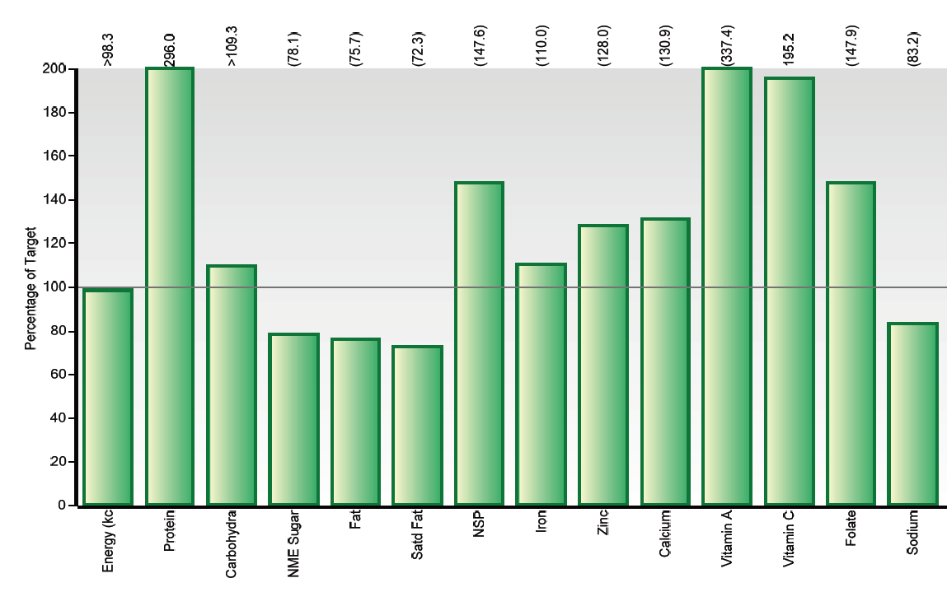
MENU: WK2A/W2012 Week Two Autumn/Winter 2012
NUTRITION RULE: Primary Lunch

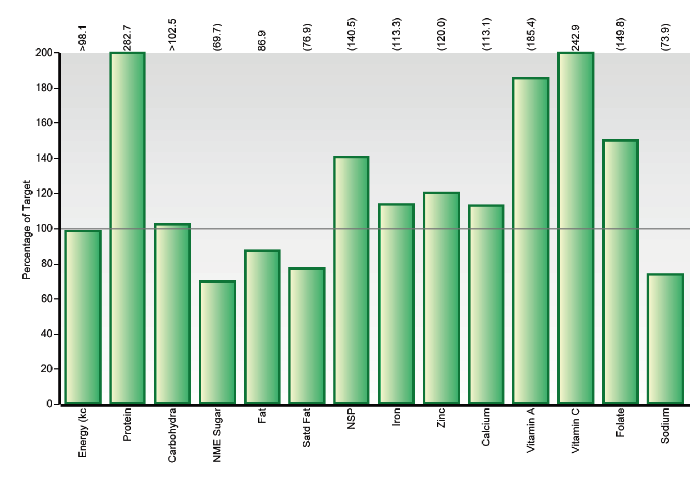
MENU: WK3A/W2012 Week Three Autumn/Winter 2012
NUTRITION RULE: Primary Lunch

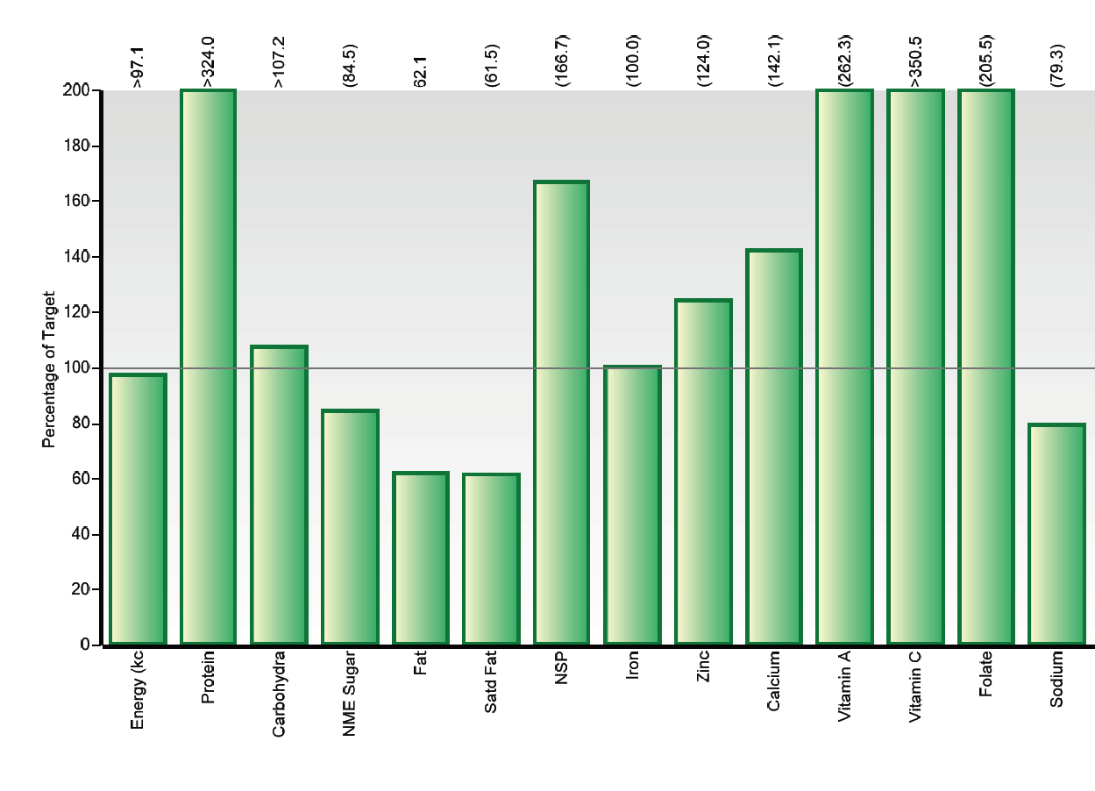
MENU: WK1A/W2012 Week One Autumn/Winter 2012

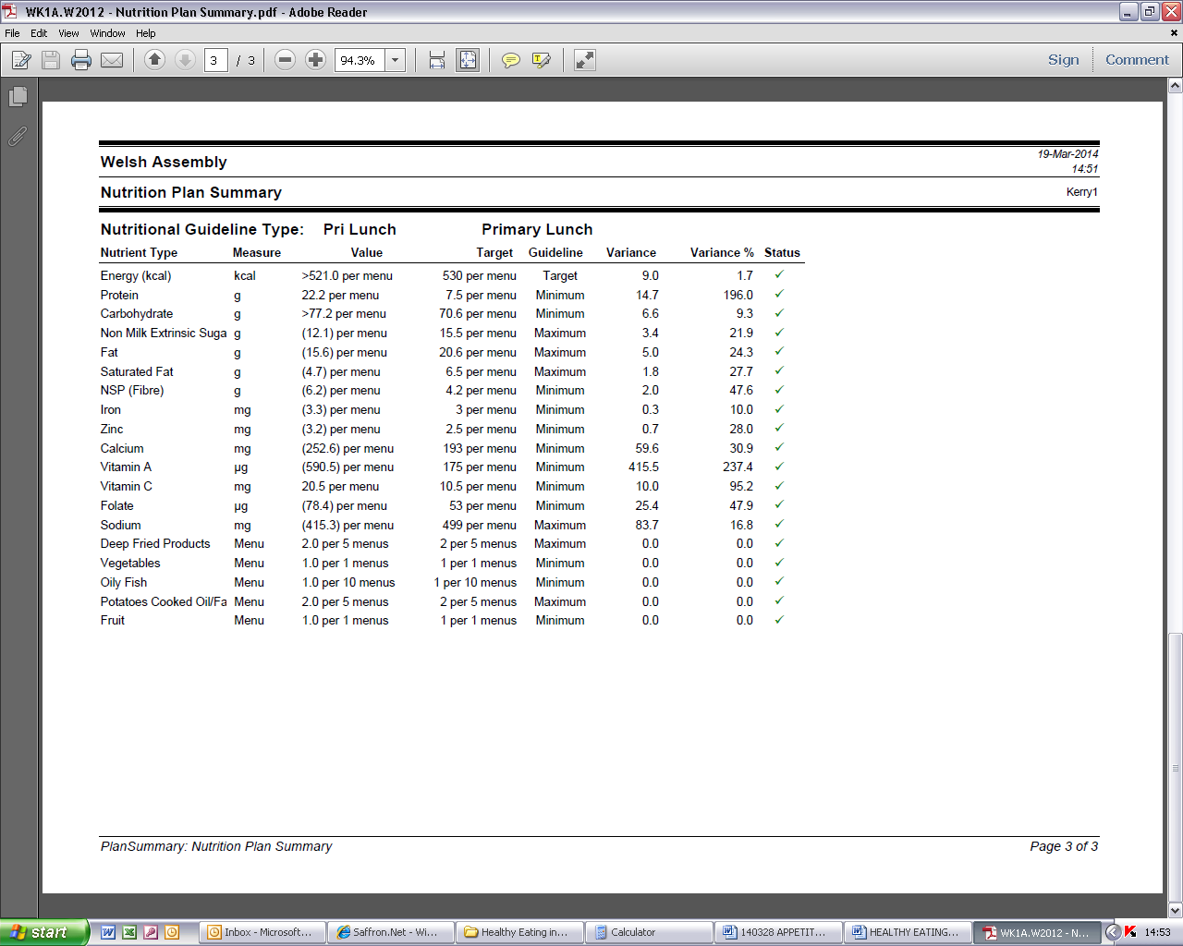
MENU: WK2A/W2012 Week Two Autumn/Winter 2012

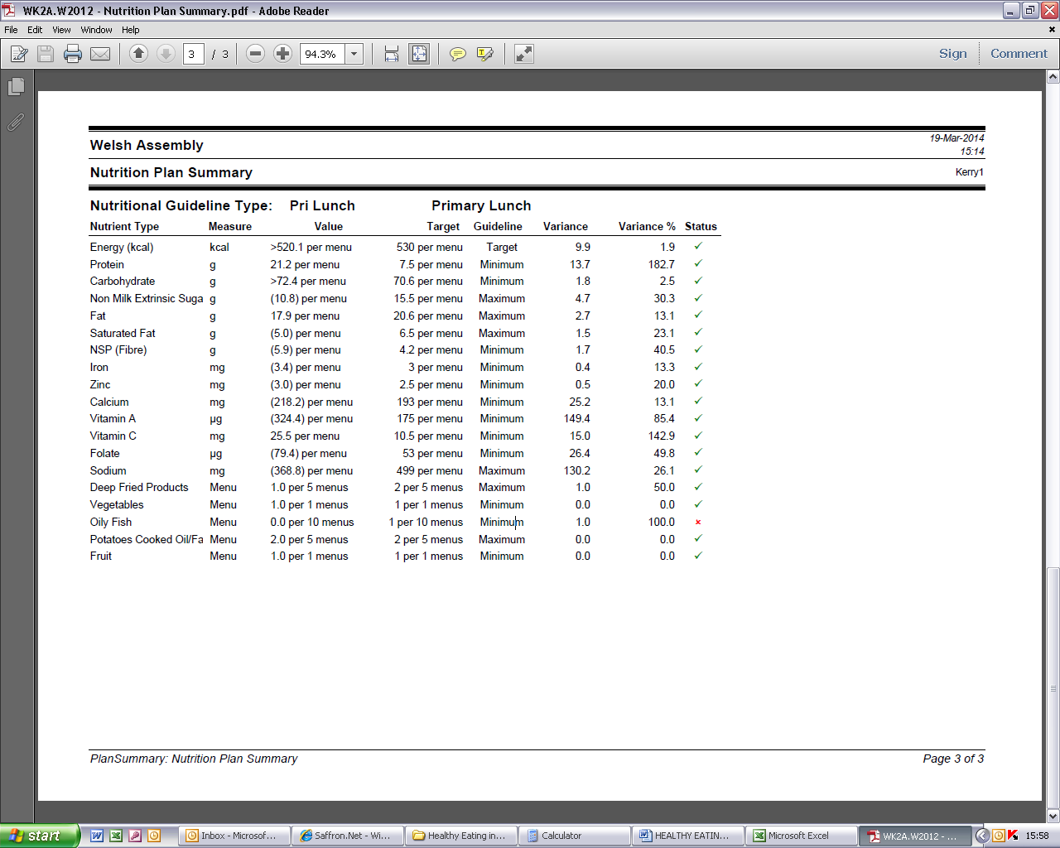
MENU: WK3A/W2012 Week Three Autumn/Winter 2012

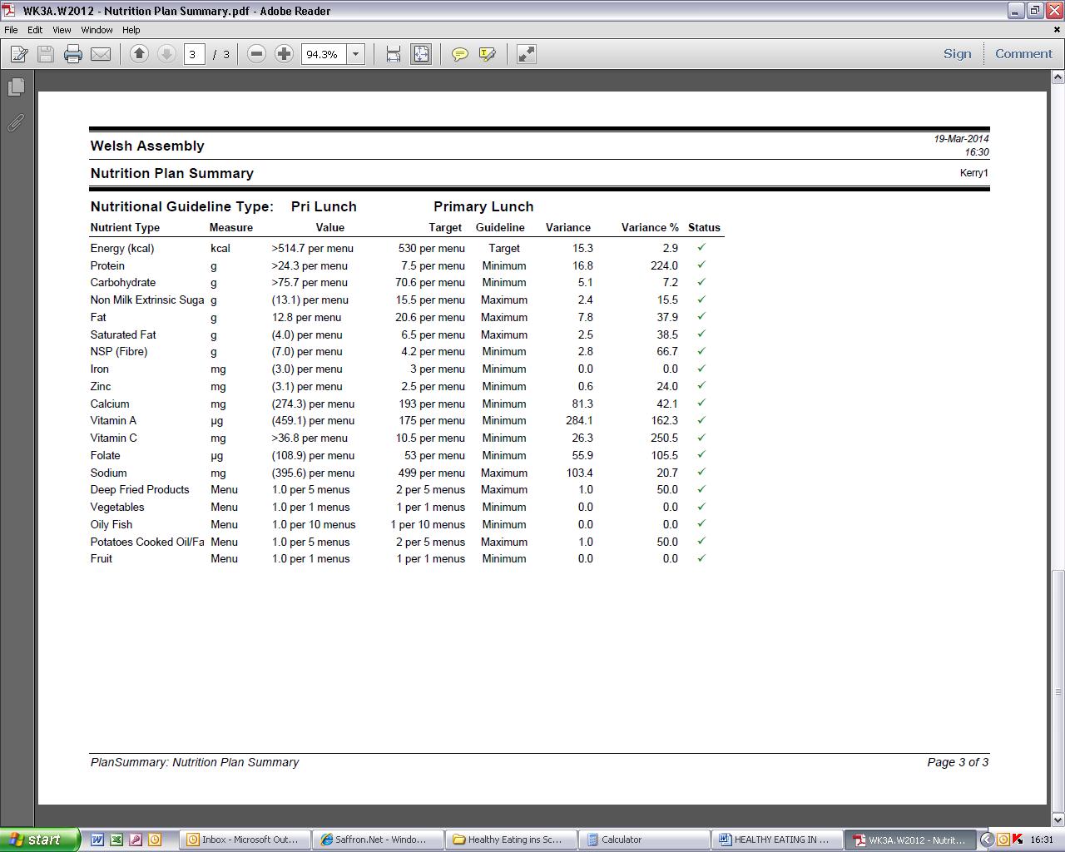
Single Drinks | Nursery | Primary | Secondary
Plain water – still or carbonated  - No added substances | Yes | Yes | Yes
Plain milk – whole, semi skimmed or skimmed  - No added substances | Whole or semi-skimmed | Semi skimmed or skimmed | Semi skimmed or skimmed
Fruit Juice and Vegetable Juice – still or carbonated  - No added substance | Yes | Yes | Yes
Plain soya, rice or oat milk  - No added substances  - May contain added calcium | Rice milk not for <5 year olds | Yes | Yes
Combination Drinks
Fruit Juice and Vegetable Juice combined with water – still or carbonated  - ≥ 50% fruit juice or vegetable juice  - No added sugars or honey | Yes – only school breakfast or lunch | Yes – only school breakfast or lunch | Yes
Fruit juice and/or vegetable juice combined with milk/yoghurt/soya/rice milk/oat milk (e.g. dairy based smoothies)  - ≥ 50%  - Must be semi-skimmed or skimmed milk  - May contain vitamins and minerals  - < 5% sugars or honey maybe added to the milk component | No | No | Yes
Flavoured milk/yoghurt/soya/ rice or oat drinks  - ≥ 90% milk/yoghurt/soya, rice or oat drink  - Must be semi-skimmed or skimmed milk  - < 5% sugars or honey maybe added to the milk, yoghurt or plain soya, rice or oat component  - May contain vitamins and minerals | No | No | Yes
Blended Drinks
Fruit and/or vegetable blends/purees (e.g. fruit/vegetable smoothies)  - Additives according to EU Regulations | Yes – only school lunch | Yes – only school lunch | Yes
Hot drinks
Tea/Coffee  - Must be semi skimmed or skimmed milk | No | No | Yes
Hot chocolate  - < 5% sugars or honey added to the milk (plain/soya/rice/oat) or water component  - Must be made with plain water/milk (semi-skimmed/skimmed)/plain soya/rice/oat drink  - May contain vitamins and minerals  - Maximum portion size of 250ml | No | No | Yes
Annex 5. Drinks standards across the whole school day

http://www.legislation.gov.uk/anaw/2013/1/section/88/enacted
http://www.legislation.gov.uk/wsi/2013/1984/contents/made
Nutritional Analysis Guide
As defined in The Fruit Juices and Nectars (Wales) Regulations 2003 SI No. 3041 (W.286).
Sugar may be added for the purpose of regulating acidic taste, in an amount (expressed as dry matter) not exceeding 15g per litre of juice as permitted by Schedule 3 paragraph 3(a) of The Fruit Juices and Nectars (Wales) Regulations 2003 SI No. 3041 (W.286).
These drinks are legally permitted to contain sweeteners, colours, flavourings and other miscellaneous additives such as preservatives, antioxidants and stabilisers as specified under EU law (Council Directive 89/107 EEC and Council Directive 88/388/EEC). They are also permitted to contain added vitamins and minerals
These drinks are legally permitted to contain sweeteners, colours, flavourings and other miscellaneous additives such as preservatives, antioxidants and stabilisers as specified under EU law (Council Directive 89/107 EEC and Council Directive 88/388/EEC). They are also permitted to contain added vitamins and minerals
These drinks are legally permitted to contain sweeteners, colours, flavourings and other miscellaneous additives such as preservatives, antioxidants and stabilisers as specified under EU law (Council Directive 89/107 EEC and Council Directive 88/388/EEC). They are also permitted to contain added vitamins and minerals
These drinks are legally permitted to contain sweeteners, colours, flavourings and other miscellaneous additives such as preservatives, antioxidants and stabilisers as specified under EU law (Council Directive 89/107 EEC and Council Directive 88/388/EEC). They are also permitted to contain added vitamins and minerals

